# REPORT SUBMISSION FORM

|  |  |  |
| --- | --- | --- |
|  | |  |
| Name: | TAN WEI LIANG | |
| Partner's Name: | AINA IMANINA BINTI MOHB KHOZIKIN | |
| Group: | M5B | |
| Experiment Code: | 1 GP 2 | |
| Experiment Title: | Projectile Motion | |
|  |  | |
| Lecturer’s / Examiner’s Name: | Dr. Edmund Loh Wai Ming | |
| Starting Date (1st session): | 27/11/2023 | |
| Ending Date (2nd session): | 11/12/2023 | |
| Submission Date: | 23/11/2023 | |

# DECLARATION OF ORIGINALITY

|  |  |  |  |
| --- | --- | --- | --- |
| I, **TAN WEI LIANG** **22302889** hereby declare that this laboratory report is my own work. I further declare that:   1. The references / bibliography reflects the sources I have consulted, and 2. I also certify that this report has not previously been submitted for assessment in this or any other units, and that I have not copied in part or whole or otherwise plagiarized the work of other students and/or persons. 3. Sections with no source referrals are my own ideas, arguments and/or conclusions. | | | |
| Signature: | |  | | --- | |  | | Date: | |  | | --- | | 23/11/2023 | |

|  |
| --- |
| **PROJECTILE MOTION** |

|  |
| --- |
| **By** |

|  |
| --- |
| **TAN WEI LIANG** |

|  |
| --- |
| **DECEMBER 2023** |

|  |
| --- |
| **First Year Laboratory Report** |

**PROJECTILE MOTION**

# ABSTRACT

The title of this experiment is Projectile Motion. This experiment explores projectile motion by analysing the trajectory of a steel ball launched at various velocities and angles relative to the horizontal using PHYWE's Projectile Motion experiment set. The study involves collecting data to establish correlations between the angle of projection and both the range and height of the projectile. The experimental results revealed a gravitational acceleration of (9.71 ± 0.01) , exhibiting a 0.92% discrepancy from the theoretical value. Additionally, it was observed that the maximum range of the projectile is directly influenced by the initial speed of the launch. This investigation provides valuable insights into the fundamental principles of projectile motion and contributes to a better understanding of the relationship between launch parameters and the resulting trajectory. Further explore, the Time of flight can be obtained from gradient of graph ofMaximum Range, S against Initial Speed, with angle of projection is 1.66 s.

# Acknowledgements

First and foremost, I express my deepest gratitude to Dr. Edmund Loh Wai Ming, our distinguished lecturer and examiner, for his invaluable guidance and unwavering support throughout our scientific exploration. His contributions as both an esteemed educator and the original creator of this laboratory manual have been instrumental to the success of our endeavours. I am truly thankful for his mentorship and the foundation he laid for our scientific understanding. I extend my sincere gratitude to my experiment partner, *Aina Imanina Binti Mohb Khozikin*. Her invaluable cooperation and dedication throughout both experiments were instrumental to the success of this project. I appreciate her commitment, expertise, and teamwork, which made these scientific endeavours both productive and enjoyable. A heartfelt acknowledgment is also extended to *Dr. John Soo Yue Han* for his dedicated efforts in revising and standardizing the manual in 2021, elevating its clarity and educational significance. This collective endeavor has significantly enhanced our scientific learning journey, and I extend genuine gratitude to everyone mentioned for their noteworthy contributions.

# CONTENTS

ABSTRACT 1

Acknowledgements 2

CONTENTS 3

LIST OF TABLES 4

LIST OF FIGURES 5

1. INTRODUCTION 6

**General Introduction** 6

2. THEORY 7

3. METHODOLOGY 13

4. DATA ANALYSYS 14

5. DISCUSSION AND CONCLUSION 15

APPENDICES 17

# LIST OF TABLES

Table 1 Experimental Data set for **Part A** experiment. 10

Table 2 Actual Initial Speed, 𝒗𝟎 (𝐦 𝐬−𝟏**)** and uncertainty 10

Table 3 Range and Height of projection with the Theoretical values and Percentage of discrepancy 11

Table 4 Values of and with uncertainties 13

Table 5 The gravitational acceleration, g obtained from the graph of against Range, S 14

Table 6 The gravitational acceleration, g obtained from the graph of Range, S against 15

Table 7 The gravitational acceleration, g obtained from the graph of against Maximum Height, h 16

Table 8 The gravitational acceleration, g obtained from the graph of Maximum Height, hagainst 17

Table 9 Results of gravitational acceleration, g, percentage of discrepancy with various initial velocity of projection and type of graph 18

Table 10 Data for **Part B** 19

Table 11 Range and Actual Initial speed with projection angle with the uncertainties 19

Table 12 Values of Uncertainty of in projection angle with uncertainties 21

Table 13 The gravitational acceleration, g obtained from the graph of against Range, S 22

Table 14 The gravitational acceleration, g obtained from the graph of Range, S against 23

Table 15 Comparison results obtained from Graph of against Range, S with Graph ofRang**e**, S against in angle of projection 24

# LIST OF FIGURES

Figure 1. Movement of a mass point under the effect of gravitational force. 6

Figure 2. Maximum height of projection ℎ as a function of angle of projection 𝜙 at different initial velocities 𝑣0 7

Figure 3. Maximum range 𝑠 as a function of angle of projection 𝜙 at different initial velocities 𝑣0. 7

Figure 4. Maximum range 𝑠 as a function of initial speed 𝑣0 with a fixed angle of projection 𝜙 = 45°. 7

Figure 5. shows the experiment setup used in this study 8

Figure 6. Graph of Range, S against Angle of Projection, *ϕ* 11

Figure 7. Graph of Maximum Height, h against Angle of Projection, *ϕ* 12

Figure 8. Graph of against Range, S 14

Figure 9. Graph ofRange, S against 15

Figure 10. Graph of h 16

Figure 11. Graph of h  17

Figure 12. Graph of Maximum Range, S against Initial Speed, 20

Figure 13. Graph of against Range, S in angle of projection 22

Figure 14. Graph ofRange, S against in angle of projection 23

# INTRODUCTION

In this experiment, we will study the projectile motion of a steel ball using PHYWE’s Projectile Motion experiment set. A steel ball is fired by a spring at different velocities and at different angles to the horizontal. Using the data collected, we will investigate the relationship between the range, height of projection, angle of projection and initial speed of the projectile.

# THEORY

## A diagram of a mass of a mass Description automatically generated with medium confidenceP**rojectile Motion**

**Figure 1:** Movement of a mass point under the effect of gravitational force.

If a body of mass 𝑚 moves in a constant gravitational field (gravitational force 𝑚𝑔⃗), the motion lies in a plane (**Figure 1**). If the coordinate system is laid in this 𝑥-𝑦 plane, the *equation of motion* 𝑟⃗(𝑡) is

|  |  |
| --- | --- |
| 𝑑2  𝑚 𝑑𝑡2 𝑟⃗(𝑡) = 𝑚𝑔⃗. | (1) |

If 𝑟⃗ = (𝑥, 𝑦) and 𝑔⃗ = (0, −𝑔), and the initial position and velocity are 𝑟⃗ (0) = (0,0) and

𝑣⃗ (0) = (𝑣0 cos 𝜙, 𝑣0 sin 𝜙), we obtain the *coordinates* as a function of time 𝑡,

|  |  |
| --- | --- |
| 𝑥(𝑡) = 𝑣0𝑡 cos 𝜙  1  𝑦(𝑡) = 𝑣0𝑡 sin 𝜙 − 𝑔𝑡2.  2 | (2) |

From this, the *maximum height* of projection ℎ is obtained as a function of the *angle of projection* 𝜙,

|  |  |
| --- | --- |
| 𝑣2  ℎ = 0 sin2 𝜙,  2𝑔 | (3) |

and the *maximum range* 𝑠 is

|  |  |
| --- | --- |
| 𝑣 2  𝑠 = 0 sin 2𝜙.  𝑔 | (4) |

**Figure 2** shows the maximum height as a function of projection angle, and we see that the higher the initial velocity, the higher the maximum height. On the other hand, the maximum range is reached at the projection angle of 45° for every initial velocity, as shown in **Figure 3**. By choosing a logarithmic scale, a regression line can be applied to the measured data and used to determine the maximum range for arbitrary initial velocities (**Figure 4**).

|  |  |
| --- | --- |
|  |  |
| **Figure 2:** Maximum height of projection ℎ as a  function of angle of projection 𝜙 at different initial velocities 𝑣0. | **Figure 3:** Maximum range 𝑠 as a function of angle of projection 𝜙 at different initial velocities 𝑣0. |

**Figure 4**: Maximum range 𝑠 as a function of initial speed 𝑣0 with a fixed angle of projection 𝜙 = 45°.

# 3. EXPERIMENTAL METHODOLOGY

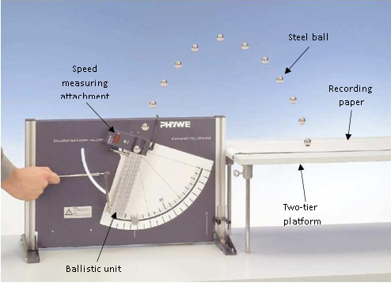

**Figure 5: shows the experiment setup used in this study**.

In part A, the apparatus, as illustrated in Figure 5, was set up with a recording strip securely affixed to the bench using adhesive tape. To measure the height of projection accurately, a meter scale was clamped in the barrel base, allowing for parallel movement along the projection plane. Impact points were marked on the recording strip, and for safety, an empty box was positioned behind the bench to catch the steel ball upon descent.

To initiate the experiment, the steel ball was placed on the striker within the ballistic unit, and the firing spring was pulled to the first tension stage, denoted as the initial speed 𝑣0,1​. The distance between the striker and the centre between the light barriers (*d*) was measured and recorded in Table 1. Subsequently, the ballistic unit was adjusted to set the angle of projection (*ϕ*) to 25°. The steel ball was then fired, and both the range (*s*) and the height of projection (*h*) were recorded in Table 1, along with the experimental initial speed (𝑣exp​).

Experiments were repeated with varying angles of projection (*ϕ*= 35°,45°,55°, and 65°). Furthermore, the experiment was replicated for the second and third tension stages, corresponding to the second and third initial velocities (𝑣0,2 ​and ​ 𝑣0,3).

For the analysis phase, the actual initial speeds (​𝑣0) were calculated using the formula ​, accounting for the time taken by the ball to cover the measuring distance. Graphs of maximum range (*s*) against angle of projection (*ϕ*) and maximum height of projection (*h*) against angle of projection (*ϕ*) were plotted for each initial velocity.

To determine the gravitational acceleration (*g*), two additional linear graphs s against and h against were plotted using the collected data for *s* against *ϕ* and *h* against *ϕ*. The value of gravitational acceleration (*g*) was then obtained from the slopes of these linear graphs. This systematic approach ensured precision in measuring and analysing the experimental data, facilitating a reliable determination of the gravitational acceleration of the Earth.

In Part B of the experiment, the objective is to investigate the relationship between the maximum range (*s*) and the initial speed (𝑣0​) of the steel ball. The procedure for this part is outlined as follows.

The experimental setup from Part A was replicated for continuity. The steel ball was placed on the striker in the ballistic unit, and the firing spring was pulled to the first tension stage, representing the first initial speed (𝑣0,1​). The distance between the striker and the centre between the light barriers (*d*) was measured and recorded in Table 2.

Subsequently, the ballistic unit was adjusted to set the angle of projection (*ϕ*) to 45°. The steel ball was then fired, and both the range (*s*) and the initial firing speed (𝑣exp​) were recorded. Steps were repeated for the second and third tension stages, corresponding to the second and third initial velocities (𝑣0,2 ​ and 𝑣0,3​).

For the analysis phase, the actual initial speeds (𝑣0​) were calculated using the formula ​. Subsequently, a graph of maximum range (*s*) against initial speed (𝑣0​) was plotted. This graph aims to reveal the nature of the relationship between the maximum range achieved by the steel ball and its initial speed.

This investigation provides valuable insights into the projectile motion of the steel ball, allowing for a comprehensive understanding of how the initial speed influences the maximum range attained. The plotted graph serves as a visual representation of this relationship, aiding in the interpretation of the experimental results.

# DATA ANALYSYS

**PART A**

|  |  |  |  |  |
| --- | --- | --- | --- | --- |
| **Angle of Projection,**  𝝓 | **Range,** 𝒔 **(±0.01 m)** | **Height of Projection,** 𝒉  **(±0.01 m)** | **Experimental Initial Speed,** 𝒗𝐞𝐱𝐩  **(±0.01** 𝐦 𝐬−𝟏**)** | **Actual Initial Speed,** 𝒗𝟎 (𝐦 𝐬−𝟏**)** |
| First initial speed, 𝑣0,1 (m s−1) [Distance, 𝑑1 = 0.050 **±0.01** m] | | | | |
| 25° | 0.485 | 0.035 | 2.32 | 2.36 |
| 35° | 0.570 | 0.039 | 2.29 | 2.35 |
| 45° | 0.590 | 0.170 | 2.30 | 2.37 |
| 55° | 0.495 | 0.210 | 2.27 | 2.36 |
| 65° | 0.460 | 0.250 | 2.30 | 2.39 |
| Second initial speed, 𝑣0,2 (m s−1) [Distance, 𝑑2 = 0.065 **±0.01** m] | | | | |
| 25° | 1.095 | 0.080 | 3.33 | 3.37 |
| 35° | 1.220 | 0.190 | 3.27 | 3.33 |
| 45° | 1.230 | 0.290 | 3.28 | 3.35 |
| 55° | 1.170 | 0.410 | 3.29 | 3.37 |
| 65° | 0.785 | 0.450 | 3.12 | 3.21 |
| Third initial speed, 𝑣0,3 (m s−1) [Distance, 𝑑3 = 0.075 **±0.01** m] | | | | |
| 25° | 1.685 | 0.160 | 4.27 | 4.31 |
| 35° | 1.890 | 0.330 | 4.24 | 4.29 |
| 45° | 2.105 | 0.510 | 4.27 | 4.33 |
| 55° | 1.945 | 0.680 | 4.26 | 4.33 |
| 65° | 1.415 | 0.720 | 3.99 | 4.07 |

**Table 1**: Experimental Data set for **Part A** experiment.

|  |  |
| --- | --- |
| **Actual Initial Speed,** 𝒗𝟎 (𝐦 𝐬−𝟏**)** | **Uncertainty of Actual Initial speed,** 𝒗𝟎 (𝐦 𝐬−𝟏**)** |
| First initial speed, 𝑣0,1 (m s−1) [Distance, 𝑑1 = 0.050 **±0.01** m] | |
| 2.36 | 0.05 |
| 2.35 | 0.07 |
| 2.37 | 0.08 |
| 2.36 | 0.09 |
| 2.39 | 0.10 |
| Second initial speed, 𝑣0,2 (m s−1) [Distance, 𝑑2 = 0.065 **±0.01** m] | |
| 3.37 | 0.05 |
| 3.33 | 0.06 |
| 3.35 | 0.08 |
| 3.37 | 0.09 |
| 3.21 | 0.10 |
| Third initial speed, 𝑣0,3 (m s−1) [Distance, 𝑑3 = 0.075 **±0.01** m] | |
| 4.31 | 0.05 |
| 4.29 | 0.06 |
| 4.33 | 0.07 |
| 4.33 | 0.08 |
| 4.07 | 0.09 |

**Table 2**: Actual Initial Speed, 𝒗𝟎 (𝐦 𝐬−𝟏**)** and uncertainty

|  |  |  |  |  |  |  |
| --- | --- | --- | --- | --- | --- | --- |
| **Angle of Projection,**  𝝓 | **Range,** 𝒔  **(±0.01 m)** | **Theoretical Range,**  **( m)** | **Percentage**  **of**  **discrepancy** | **Height of Projection,** 𝒉  **(±0.01 m)** | **Theoretical**  **Height of Projection**  **(m)** | **Percentage**  **of**  **discrepancy** |
| First initial speed, 𝑣0,1 (m s−1) [Distance, 𝑑1 = 0.050 **±0.01** m] | | | | |  |  |
| 25° | 0.485 | 0.435 | 11.51 | 0.035 | 0.051 | 30.97 |
| 35° | 0.570 | 0.529 | 7.75 | 0.039 | 0.093 | 57.88 |
| 45° | 0.590 | 0.573 | 3.04 | 0.170 | 0.143 | 18.76 |
| 55° | 0.495 | 0.534 | 7.22 | 0.210 | 0.190 | 10.25 |
| 65° | 0.460 | 0.446 | 3.13 | 0.250 | 0.239 | 4.54 |
| Second initial speed, 𝑣0,2 (m s−1) [Distance, 𝑑2 = 0.065 **±0.01** m] | | | | |  |  |
| 25° | 1.095 | 0.887 | 23.47 | 0.080 | 0.103 | 22.62 |
| 35° | 1.220 | 1.062 | 14.86 | 0.190 | 0.186 | 2.18 |
| 45° | 1.230 | 1.144 | 7.52 | 0.290 | 0.286 | 1.40 |
| 55° | 1.170 | 1.088 | 7.55 | 0.410 | 0.388 | 5.56 |
| 65° | 0.785 | 0.805 | 2.44 | 0.450 | 0.431 | 4.32 |
| Third initial speed, 𝑣0,3 (m s−1) [Distance, 𝑑3 = 0.075 **±0.01** m] | | | | |  |  |
| 25° | 1.685 | 1.451 | 16.16 | 0.160 | 0.169 | 5.38 |
| 35° | 1.890 | 1.763 | 7.21 | 0.330 | 0.309 | 6.93 |
| 45° | 2.105 | 1.911 | 10.14 | 0.510 | 0.478 | 6.74 |
| 55° | 1.945 | 1.796 | 8.30 | 0.680 | 0.641 | 6.05 |
| 65° | 1.415 | 1.294 | 9.39 | 0.720 | 0.693 | 3.82 |

**Table 3**: Range and Height of projection with the Theoretical values and Percentage of discrepancy

Based on the **Table 3,** increase in the initial speed of projection results in a decrease in the percentage of discrepancy of both range and height. Conversely, in the case of the angle of projection, an increase leads to a decrease in the percentage of discrepancy both range and height.Top of Form

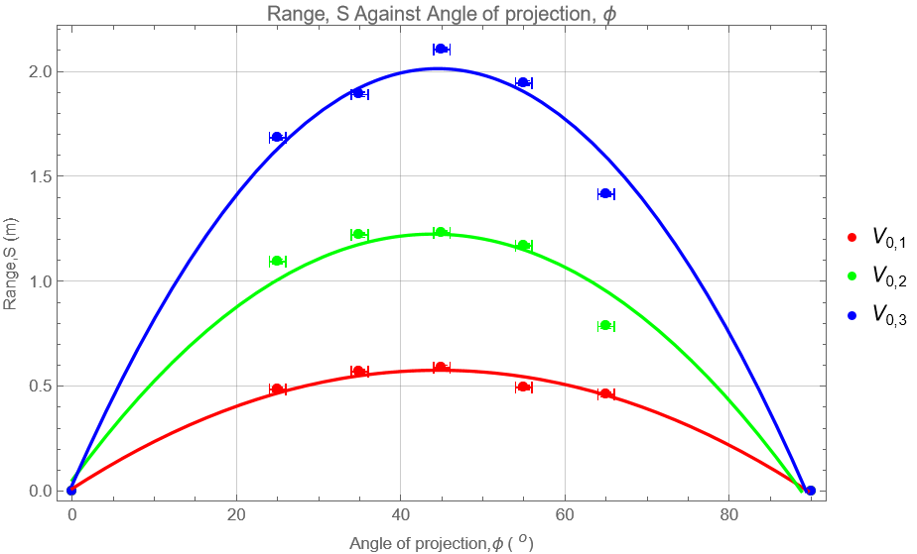

**Figure 6**: Graph of Range, S against Angle of Projection, *ϕ*

Based on Figure 6, it can be observed that a higher initial speed of projection leads to a greater range, assuming the angle of projection remains constant.

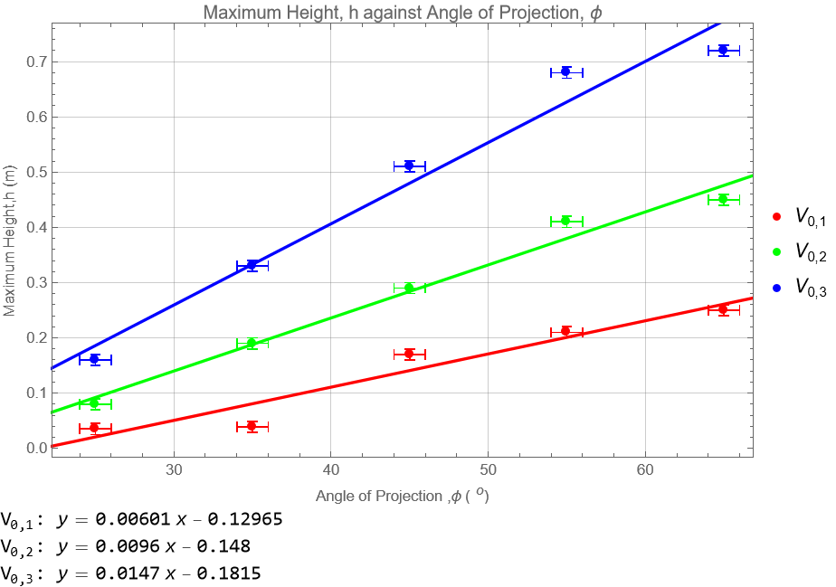**Figure 7**: Graph of Maximum Height, h against Angle of Projection, *ϕ*

In theory, the graph of the maximum height, h against the angle of projection, *ϕ* is expected to exhibit a slightly logistic increase, particularly becoming more pronounced at higher initial speeds. However, Figure 7 suggests modelling this relationship as a linear graph. This linear approximation is suitable when the initial speed is low, simplifying the representation of the projectile motion. Notably, it becomes evident that a higher initial speed of projection corresponds to a greater maximum height, assuming the angle of projection remains constant.

|  |  |  |  |  |  |  |
| --- | --- | --- | --- | --- | --- | --- |
| **Angle of Projection,**  𝝓 | **Range,** 𝒔  **(±0.01 m)** | **Height of Projection,** 𝒉  **(±0.01 m)** | () | Uncertainty of  () | () | Uncertainty of  () |
| First initial speed, 𝑣0,1 (m s−1) [Distance, 𝑑1 = 0.050 **±0.01** m] | | | | | | |
| 25° | 0.485 | 0.035 | 4.27 | 1.06 | 0.50 | 0.03 |
| 35° | 0.570 | 0.039 | 5.19 | 1.08 | 0.91 | 0.06 |
| 45° | 0.590 | 0.170 | 5.62 | 1.12 | 1.40 | 0.10 |
| 55° | 0.495 | 0.210 | 5.23 | 1.12 | 1.87 | 0.16 |
| 65° | 0.460 | 0.250 | 4.38 | 1.13 | 2.35 | 0.21 |
| Second initial speed, 𝑣0,2 (m s−1) [Distance, 𝑑2 = 0.065 **±0.01** m] | | | | | | |
| 25° | 1.095 | 0.080 | 8.70 | 2.14 | 1.01 | 0.05 |
| 35° | 1.220 | 0.190 | 10.42 | 2.11 | 1.82 | 0.09 |
| 45° | 1.230 | 0.290 | 11.22 | 2.16 | 2.81 | 0.15 |
| 55° | 1.170 | 0.410 | 10.67 | 2.19 | 3.81 | 0.21 |
| 65° | 0.785 | 0.450 | 7.89 | 1.99 | 4.23 | 0.27 |
| Third initial speed, 𝑣0,3 (m s−1) [Distance, 𝑑3 = 0.075 **±0.01** m] | | | | | | |
| 25° | 1.685 | 0.160 | 14.23 | 3.48 | 1.66 | 0.08 |
| 35° | 1.890 | 0.330 | 17.29 | 3.47 | 3.03 | 0.12 |
| 45° | 2.105 | 0.510 | 18.75 | 3.55 | 4.69 | 0.19 |
| 55° | 1.945 | 0.680 | 17.62 | 3.56 | 6.29 | 0.27 |
| 65° | 1.415 | 0.720 | 12.69 | 3.15 | 6.80 | 0.33 |

**Table 4**: Values of and with uncertainties

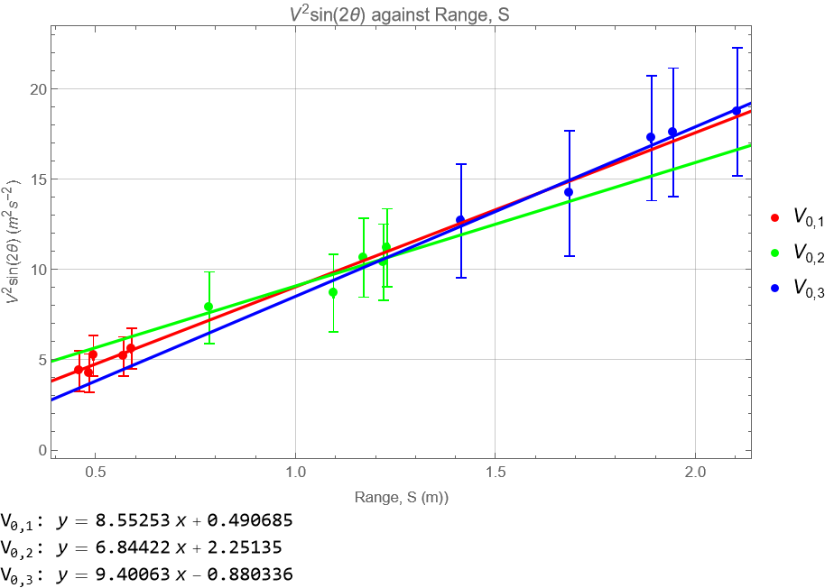

**Figure 8:** Graph of against Range, S

Since,

, which g is a constant

Thus**,** gravitational acceleration, g is the gradient of graph of against Range, S

|  |  |  |
| --- | --- | --- |
| Initial velocity of projection, | Gravitational acceleration, g | Percentage of discrepancy from =9.81 |
|  | 8.55 | 12.84 |
|  | 6.84 | 30.28 |
|  | 9.40 | 4.18 |

**Table 5**: The gravitational acceleration, g obtained from the graph of against Range, S

Calculate the percentage of discrepancy,

, where is 9.81

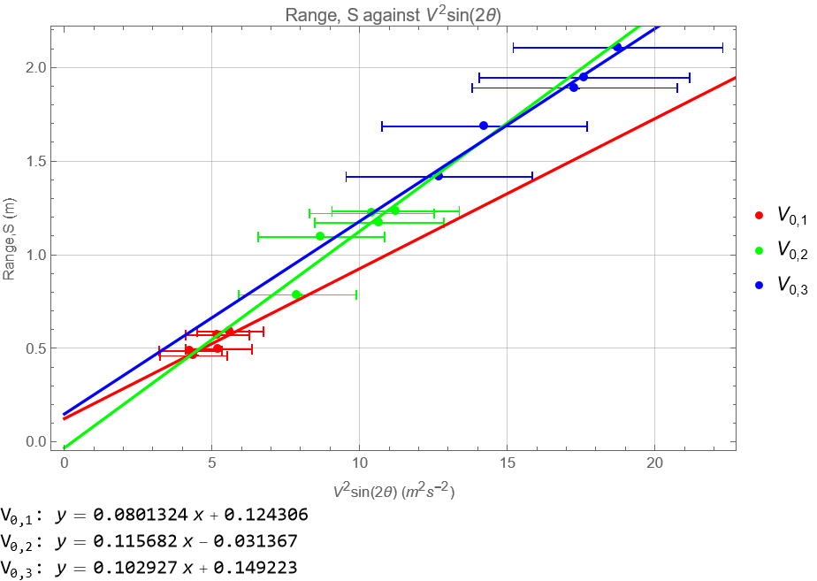

**Figure 9:** Graph ofRange, S against

Since,

, which is a constant

Thus**,** gravitational acceleration, g is the gradient of graph of against Range, S

|  |  |  |
| --- | --- | --- |
| Initial velocity of projection, | Gravitational acceleration, g | Percentage of discrepancy from =9.81 |
|  | 12.48 | 27.22 |
|  | 8.64 | 11.93 |
|  | 9.72 | 0.92 |

**Table** **6**: The gravitational acceleration, g obtained from the graph of Range, S against

Calculate the percentage of discrepancy,

, where is 9.81

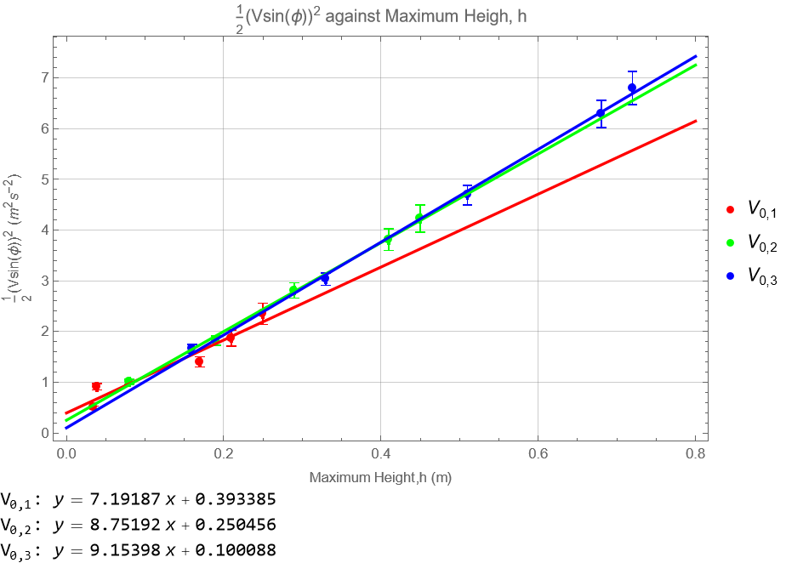

**Figure 10:** Graph of h

Since,

, which g is a constant

Thus, gravitational acceleration, g is the gradient of graph of against Maximum Height, h.

|  |  |  |
| --- | --- | --- |
| Initial velocity of projection, | Gravitational acceleration, g | Percentage of discrepancy from =9.81 |
|  | 7.19 | 26.71 |
|  | 8.75 | 10.81 |
|  | 9.15 | 6.73 |

**Table 7**: The gravitational acceleration, g obtained from the graph of against Maximum Height, h

Calculate the percentage of discrepancy,

, where is 9.81

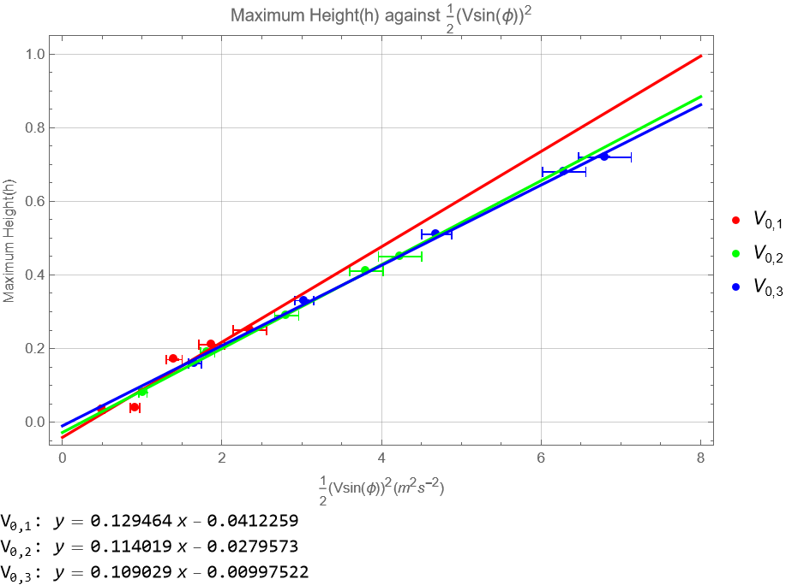

**Figure 11:** Graph of h

Since,

, which is a constant

Thus, gravitational acceleration, g is the gradient of graph of against Maximum Height, h.

|  |  |  |
| --- | --- | --- |
| Initial velocity of projection, | Gravitational acceleration, g | Percentage of discrepancy from =9.81 |
|  | 7.72 | 21.30 |
|  | 8.77 | 10.60 |
|  | 9.17 | 6.52 |

**Table** **8**: The gravitational acceleration, g obtained from the graph of Maximum Height, h against

Calculate the percentage of discrepancy,

, where is 9.81

|  |  |  |  |
| --- | --- | --- | --- |
| Type of Graph | Initial velocity of projection, | Gravitational acceleration, g | Percentage of discrepancy from =9.81 |
| Graph of against Range, S |  | 8.55 | 12.84 |
|  | 6.84 | 30.28 |
|  | 9.40 | 4.18 |
| Graph ofRange, S against |  | 12.48 | 27.22 |
|  | 8.64 | 11.93 |
|  | 9.72 | 0.92 |
| Graph of against h |  | 7.19 | 26.71 |
|  | 8.75 | 10.81 |
|  | 9.15 | 6.73 |
| Graph of h |  | 7.72 | 21.30 |
|  | 8.77 | 10.60 |
|  | 9.17 | 6.52 |

**Table** **9**: Results of gravitational acceleration, g, percentage of discrepancy with various initial velocity of projection and type of graph

According to the data presented in the table, the incremental adjustments in the initial velocity of projection result in the gravitational acceleration values converging towards the actual gravitational acceleration of Earth. Notably, the graph's gradient derived from ​ yields a more precise estimation of the gravitational acceleration compared to the gradient obtained using g.

Analysing the graphs generated from the parameters of Range, S , it is evident that they exhibit a smaller percentage of discrepancy at the highest initial velocity of projection, in contrast to the graphs derived from parameters such as h . Consequently, the gravitational acceleration of Earth is determined by selecting the value with the smallest percentage of discrepancy, amounting to 0.92%, resulting in ( 9.72 0.01) ., in close proximity to the accepted value of=9.81 . This refined selection enhances the accuracy of the gravitational acceleration determination.

**PART B**

|  |  |  |  |
| --- | --- | --- | --- |
| Experimental Initial Speed, 𝒗𝐞𝐱𝐩  (𝐦 𝐬−𝟏) | Distance, 𝒅  (±0.01 m) | Range, 𝒔  (±0.01 m) | Actual Initial Speed, 𝒗𝟎  (𝐦 𝐬−𝟏) |
| 2.31 | 0.050 | 0.595 | 2.38 |
| 2.95 | 0.065 | 1.215 | 3.03 |
| 4.08 | 0.075 | 2.100 | 4.14 |

**Table 10**: Data for **Part B**.

|  |  |  |  |  |  |
| --- | --- | --- | --- | --- | --- |
| Experimental Initial Speed, 𝒗𝐞𝐱𝐩  (𝐦 𝐬−𝟏) | Distance, 𝒅  (±0.01 m) | Range, 𝒔  (±0.01 m) | Uncertainty of  Range, 𝒔  (±0.01 m) | Actual Initial Speed, 𝒗𝟎  (𝐦 𝐬−𝟏) | Uncertainty of Actual Initial Speed, 𝒗𝟎  (𝐦 𝐬−𝟏) |
| 2.31 | 0.050 | 0.595 | 0.001 | 2.38 | 0.08 |
| 2.95 | 0.065 | 1.215 | 0.001 | 3.03 | 0.08 |
| 4.08 | 0.075 | 2.100 | 0.001 | 4.14 | 0.07 |

**Table 11**: Range and Actual Initial speed with projection angle with the uncertainties

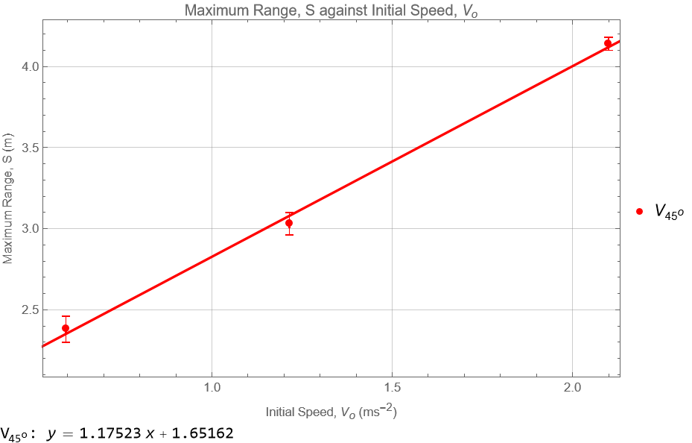**Figure 12**: Graph of Maximum Range, S against Initial Speed,

Based on Figure 10, it can be observed that a higher initial speed of projection leads to a greater range, when the angle of projection remains .

Since,

where is the horizontal component of the initial velocity. For a launch angle of 45∘,

Thus,

which is a constant

Thus**,** is the gradient of graph ofMaximum Range, S against Initial Speed,

Gradient = = 1.17523 s

Time of Flight, T= 1.17523 s =1.66 s

|  |  |  |  |  |
| --- | --- | --- | --- | --- |
| **Angle of Projection,**  𝝓 | First initial speed, 𝑣0  (m s−1) | **Range,** 𝒔  **(±0.01 m)** | () | Uncertainty of  () |
| 45° | 2.38 | 0.595 | 5.62 | 1.12 |
| 45° | 3.03 | 1.215 | 5.23 | 1.12 |
| 45° | 4.1 | 2.100 | 4.38 | 1.13 |

**Table 12**: Values of Uncertainty of in projection angle with uncertainties

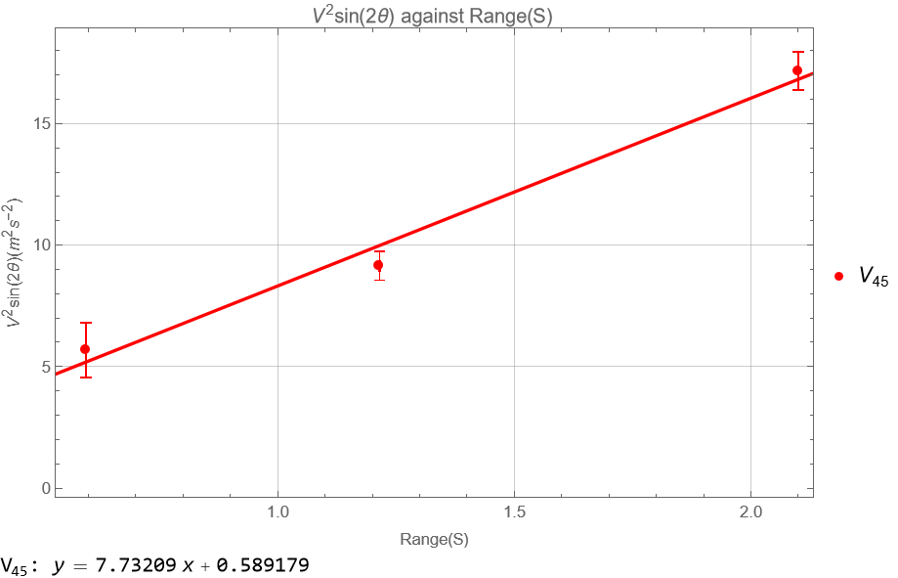

**Figure 13:** Graph of against Range, S in angle of projection

Since,

, which g is a constant

Thus**,** gravitational acceleration, g is the gradient of graph of against Range, S

|  |  |  |
| --- | --- | --- |
| Initial velocity of projection, | Gravitational acceleration, g | Percentage of discrepancy from =9.81 |
|  | 7.73 | 21.20 |

**Table** **13**: The gravitational acceleration, g obtained from the graph of against Range, S

Calculate the percentage of discrepancy,

, where is 9.81

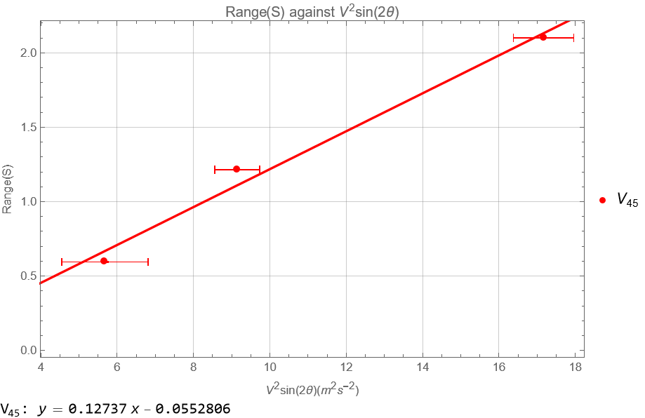

**Figure 14:** Graph ofRange, S against in angle of projection

Since,

, which is a constant

Thus**,** gravitational acceleration, g is the gradient of graph of against Range, S

|  |  |  |
| --- | --- | --- |
| Initial velocity of projection, | Gravitational acceleration, g | Percentage of discrepancy from =9.81 |
|  | 7.85 | 19.98 |

**Table** **14**: The gravitational acceleration, g obtained from the graph of Range, S against

Calculate the percentage of discrepancy,

, where is 9.81

|  |  |  |  |
| --- | --- | --- | --- |
| Type of graph | Initial velocity of projection, | Gravitational acceleration, g | Percentage of discrepancy from =9.81 |
| Graph of against Range, S in angle of projection |  | 7.73 | 21.20 |
| Graph ofRang**e**, S against in angle of projection |  | 7.85 | 19.98 |

**Table** **15**: Comparison results obtained from Graph of against Range, S with Graph ofRang**e**, S against in angle of projection

Based on the table, affirmed that Graph of against Range, Compared to Graph ofRang**e**, S against having more accuracy value of gravitational acceleration with lower percentage of discrepancy from actual value.

# 5. DISCUSSION AND CONCLUSION

**Discussion**

In Part A of the experiment, a comprehensive examination of projectile motion unveils intriguing dynamics. From the calculation of raw data, higher initial speeds resulted in decreased discrepancies, aligning with fundamental principles of projectile motion. Additionally, an increase in the angle of projection demonstrated a similar effect, suggesting certain launch angles contribute to more accurate predictions. Initially, the range experiences a swift ascent, followed by a gradual increase as the angle of projection escalates. Remarkably, the range attains its zenith at a 45° projection angle, in alignment with theoretical expectations. After this optimal angle, the range undergoes a precipitous decline with increasing projection angles beyond 45°.

Simultaneously, the height of the projectile exhibits a proportional augmentation in response to the varying projection angles. This phenomenon is rooted in the sustained increase in the vertical component, persisting even beyond the 45° angle. Consequently, the height demonstrates a consistent increase as the projection angle varies.

Moreover, the influence of initial speed on the projectile's range is discernible, with an escalation in the initial speed correlating with a notable increase in the overall range. Noteworthy is the resilience of the observed pattern of range variation with respect to projection angles across different tension stages, corresponding to diverse initial velocities. This consistency underscores the robust nature of the observed patterns, providing valuable insights into the intricate interplay between launch parameters and resultant projectile motion. The stepwise increments in the initial velocity of projection lead to gravitational acceleration values that converge towards the actual gravitational acceleration of Earth. Significantly, the graph's slope derived from ​ provides a more accurate estimation of gravitational acceleration compared to the slope obtained using *g*.

Upon scrutinizing the graphs generated from the parameters of Range, *S* and , it becomes evident that they exhibit a smaller percentage of discrepancy at the highest initial velocity of projection, in contrast to the graphs derived from parameters such as maximum Height, *h* and . Consequently, the determination of Earth's gravitational acceleration involves selecting the value with the smallest percentage of discrepancy, which amounts to 0.92%. This selection results in a refined value of gravitational acceleration of earth is ( 9.72 0.01) . This precision enhances the reliability of our discussion in the physics report's analysis and interpretation section.

For Part B, higher initial speed of projection leads to a greater range, when the angle of projection remains prove that the maximum projectile range as a function of initial speed. Based on the graph, Time of Flight, T =1.66 s can be obtained from the graph ofMaximum Range, S against Initial Speed,. Under the projection angle proving again thatGraph of against Range, S Compared to Graph ofRang**e**, S against having more accuracy value of gravitational acceleration with lower percentage of discrepancy from actual value.

In the projectile motion experiment, sources of error were identified to understand potential discrepancies in the results. Human factors, including reaction time during projectile release and visual judgment in tracking motion, were recognized as sources of uncertainty. Variability among individuals and the potential impact of fatigue further contribute to potential errors associated with human factors. Another source of error is imperfect launch conditions, characterized by variations in initial velocity, launch angle, and direction, posed challenges in achieving consistent and precise launch parameters. This variability introduces complexities that can lead to observable discrepancies in the observed projectile motion.

The suggestion of improving the experiment is utilization of high-speed photography technology significantly improves the accuracy of measurements during projectile motion, specifically in capturing the trajectory and velocity of the projectile during its flight. This technological integration minimizes errors associated with rapid changes in motion. The concurrent use of real-time analysis software further enhances the experiment's efficiency by allowing prompt processing of captured images, reducing data processing delays. Incorporating multi-angle photography provides a more comprehensive view of the projectile's motion, aiding in the identification and correction of potential parallax errors. The strategic placement of calibration markers contributes to precise measurements of height and trajectory when employing high-speed photography.

**Conclusion**

From this experiment, concluded that the range, S and height, h of projection are functions of the angle of projection. The experimental gravitational acceleration is exhibits a small percentage of discrepancy of 0.92% when compared to the theoretical value 9.81 . There is insignificant deviation between the theoretical and experimental gravitational accelerations. Also conclude that the maximum projectile range as a function of initial speed, that a higher initial speed of projection leads to a greater range. Further explore, the Time of flight obtained from gradient of graph ofMaximum Range, S against Initial Speed, with angle of projection is 1.66 s.

# 6. REFERENCES

1. PHYWE (2019). Student’s Sheet for *Projectile Motion (P2131100)*.
2. PhysChem EMU (2020). *EMU Physics Department: “Projectile Motion” Experiment.*

Retrieved 5 Aug 2021 from [youtube.com.](https://www.youtube.com/watch?v=zsOZWW1fb4c)

# APPENDICES

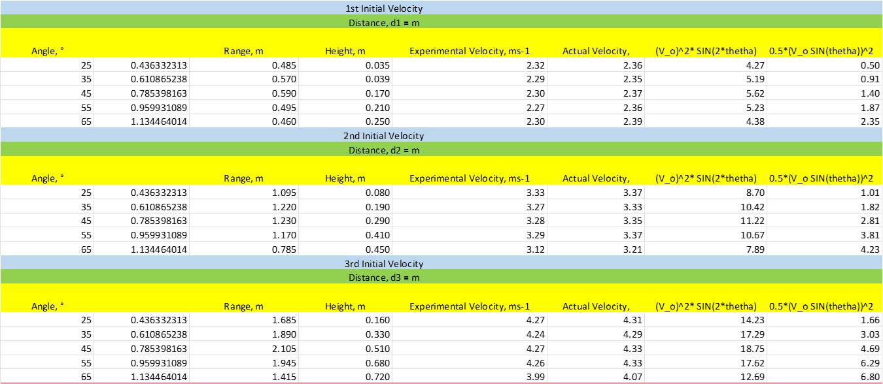Appendices 1: Calculation of data in PART A by EXCEL

Appendices 2: Calculation of theoretical range and height with percentage discrepancy by Excel



Appendices 3: Uncertainty of calculation in PART A by EXCEL

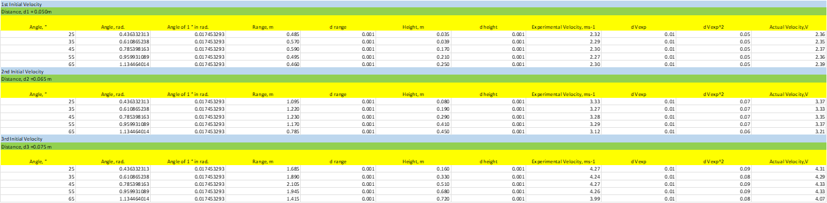

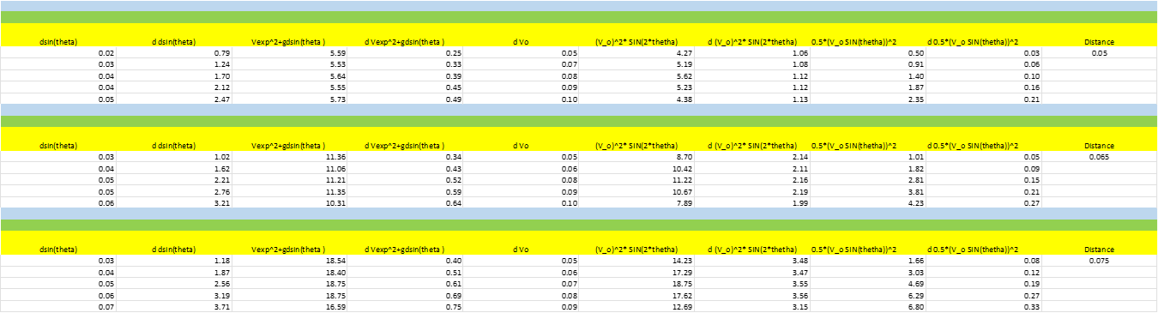

Appendices 4: Calculation and uncertainties of data in PART B by EXCEL



Appendices 5: Code in Mathematica for Graph of Range, S against Angle of Projection, ϕ

V1={{0,0},{25,0.485},{35,0.570},{45,0.590},{55,0.495},{65,0.460},{90,0}};

V2={{0,0},{25,1.095},{35,1.220},{45,1.230},{55,1.170},{65,0.785},{90,0}};

V3={{0,0},{25,1.685},{35,1.890},{45,2.105},{55,1.945},{65,1.415},{90,0}};

V1error={

{Around[25,1],Around[0.485,0.01]},{Around[35,1],Around[0.570,0.01]},{Around[45,1],Around[0.590,0.01]},{Around[55,1],Around[0.495,0.01]},{Around[65,1],Around[0.460,0.01]}};

V2error={

{Around[25,1],Around[1.095,0.01]},{Around[35,1],Around[1.220,0.01]},{Around[45,1],Around[1.230,0.01]},{Around[55,1],Around[1.170,0.01]},{Around[65,1],Around[0.785,0.01]}};

V3error={

{Around[25,1],Around[1.685,0.01]},{Around[35,1],Around[1.890,0.01]},{Around[45,1],Around[2.105,0.01]},{Around[55,1],Around[1.945,0.01]},{Around[65,1],Around[1.415,0.01]}};

(*Extracting x and y values for each group*)

x1=V1[[All,1]];

y1=V1[[All,2]];

x2=V2[[All,1]];

y2=V2[[All,2]];

x3=V3[[All,1]];

y3=V3[[All,2]];

(*Fitting curves for each group*)

fit1=Fit[Transpose[{x1,y1}],{1,x,x^2},x];

fit2=Fit[Transpose[{x2,y2}],{1,x,x^2},x];

fit3=Fit[Transpose[{x3,y3}],{1,x,x^2},x];

(*Plotting the data points and best-fit curves with extended range*)

Show[

ListPlot[{V1,V2,V3},PlotStyle->{Red,Green,Blue}],

ListPlot[{V1error,V2error,V3error},PlotStyle->{Red,Green,Blue},PlotLegends->{"\!\(\*SubscriptBox[\(V\), \(0, 1\)]\)","\!\(\*SubscriptBox[\(V\), \(0, 2\)]\)","\!\(\*SubscriptBox[\(V\), \(0, 3\)]\)"}],Plot[{fit1,fit2,fit3},{x,0,100},PlotStyle->{Red,Green,Blue},PlotRange->{{0,100},{0,Max[y3]}}],Frame->True,FrameLabel->{"Angle of projection,ϕ ( o)","Range,S (m)"},GridLines->Automatic,PlotLabel->"Range, S Against Angle of projection, ϕ",ImageSize->500]

Appendices 6: Code in Mathematica for Graph of Maximum Height, h against Angle of Projection, *ϕ*

(*Define the datasets*)V1={{25,0.035},{35,0.039},{45,0.170},{55,0.210},{65,0.250}};

V2={{25,0.080},{35,0.190},{45,0.290},{55,0.410},{65,0.450}};

V3={{25,0.160},{35,0.330},{45,0.510},{55,0.680},{65,0.720}};

V1error={

{Around[25,1],Around[0.035,0.01]},{Around[35,1],Around[0.039,0.01]},{Around[45,1],Around[0.170,0.01]},{Around[55,1],Around[0.210,0.01]},{Around[65,1],Around[0.250,0.01]}};

V2error={

{Around[25,1],Around[0.080,0.01]},{Around[35,1],Around[0.190,0.01]},{Around[45,1],Around[0.290,0.01]},{Around[55,1],Around[0.410,0.01]},{Around[65,1],Around[0.450,0.01]}};

V3error={

{Around[25,1],Around[0.160,0.01]},{Around[35,1],Around[0.330,0.01]},{Around[45,1],Around[0.510,0.01]},{Around[55,1],Around[0.680,0.01]},{Around[65,1],Around[0.720,0.01]}};

(*Fit linear models to the data*)

fitV1=LinearModelFit[V1,x,x];

fitV2=LinearModelFit[V2,x,x];

fitV3=LinearModelFit[V3,x,x];

(*Extract equations as strings*)

eq1=ToString[TraditionalForm[y==fitV1["BestFit"]]];

eq2=ToString[TraditionalForm[y==fitV2["BestFit"]]];

eq3=ToString[TraditionalForm[y==fitV3["BestFit"]]];

(*Plot the data and the best-fit lines*)

Column[{combinedPlot=Show[ListPlot[{V1error,V2error,V3error},PlotStyle->{Red,Green,Blue},PlotLegends->{"\!\(\*SubscriptBox[\(V\), \(0, 1\)]\)","\!\(\*SubscriptBox[\(V\), \(0, 2\)]\)","\!\(\*SubscriptBox[\(V\), \(0, 3\)]\)"}],Plot[{fitV1[x],fitV2[x],fitV3[x]},{x,0,90},PlotStyle->{Red,Green,Blue},PlotRange->{{0,90},Automatic}],Frame->True,FrameLabel->{"Angle of Projection ,\[Phi] ( ^o)","Maximum Height,h (m)"},GridLines->Automatic,PlotLabel->"Maximum Height, h against Angle of Projection, \[Phi]",ImageSize->500],Column[{Row[{"\!\(\*SubscriptBox[\(V\), \(0, 1\)]\): ",eq1}],Row[{"\!\(\*SubscriptBox[\(V\), \(0, 2\)]\): ",eq2}],Row[{"\!\(\*SubscriptBox[\(V\), \(0, 3\)]\): ",eq3}]}]}]

Appendices 7: Code in Mathematica for Graph of against Range, S

(*Define the data*)

V1={{0.485,4.27},{0.570,5.19},{0.590,5.62},{0.495,5.23},{0.460,4.38}};

V2={{1.095,8.70},{1.220,10.42},{1.230,11.22},{1.170,10.67},{0.785,7.89}};

V3={{1.685,14.23},{1.890,17.29},{2.105,18.75},{1.945,17.62},{1.415,12.69}};

(*error bar*)

V1error={

{Around[0.485,0.001],Around[4.27,1.06]},{Around[0.570,0.001],Around[5.19,1.08]},{Around[0.590,0.001],Around[5.62,1.12]},{Around[0.495,0.001],Around[5.23,1.12]},{Around[0.460,0.001],Around[4.38,1.13]}

};

V2error={

{Around[1.095,0.001],Around[8.70,2.14]},{Around[1.220,0.001],Around[10.42,2.11]},{Around[1.230,0.001],Around[11.22,2.16]},{Around[1.170,0.001],Around[10.67,2.19]},{Around[0.785,0.001],Around[7.89,1.99]}

};

V3error={

{Around[1.685,0.001],Around[14.23,3.48]},{Around[1.890,0.001],Around[17.29,3.47]},{Around[2.105,0.001],Around[18.75,3.55]},{Around[1.945,0.001],Around[17.62,3.56]},{Around[1.415,0.001],Around[12.69,3.15]}

};

(*Extract x and y values for each set of data*)

x1=V1[[All,1]];

y1=V1[[All,2]];

x2=V2[[All,1]];

y2=V2[[All,2]];

x3=V3[[All,1]];

y3=V3[[All,2]];

(*Perform linear regression to find the best-fit lines*)

fit1=LinearModelFit[V1,x,x];

fit2=LinearModelFit[V2,x,x];

fit3=LinearModelFit[V3,x,x];

(*Extract equations as strings*)

eq1=ToString[TraditionalForm[y==fit1["BestFit"]]];

eq2=ToString[TraditionalForm[y==fit2["BestFit"]]];

eq3=ToString[TraditionalForm[y==fit3["BestFit"]]];

(*Display the equations outside the graph with extended line plot*)

Column[{Show[ListPlot[{V1error,V2error,V3error},PlotStyle->{Red,Green,Blue},PlotLegends->{"\!\(\*SubscriptBox[\(V\), \(0, 1\)]\)","\!\(\*SubscriptBox[\(V\), \(0, 2\)]\)","\!\(\*SubscriptBox[\(V\), \(0, 3\)]\)"}],Plot[{fit1[x],fit2[x],fit3[x]},{x,0,2.5},PlotStyle->{Red,Green,Blue},PlotRange->{{0,2.5},Automatic}],Frame->True,FrameLabel->{"Range, S (m))","\!\(\*SuperscriptBox[\(V\), \(2\)]\)sin(2\[Theta]) (m^2s^-2)"},GridLines->Automatic,PlotLabel->"\!\(\*SuperscriptBox[\(V\), \(2\)]\)sin(2\[Theta]) against Range, S ",ImageSize->500],Column[{Row[{"\!\(\*SubscriptBox[\(V\), \(0, 1\)]\): ",eq1}],Row[{"\!\(\*SubscriptBox[\(V\), \(0, 2\)]\): ",eq2}],Row[{"\!\(\*SubscriptBox[\(V\), \(0, 3\)]\): ",eq3}]}]}]

Appendices 8: Code in Mathematica for Graph ofRange, S against

{Around[14.23,3.48],Around[1.685,0.001]},{Around[17.29,3.47],Around[1.890,0.001]},{Around[18.75,3.55],Around[2.105,0.001]},{Around[17.62,3.56],Around[1.945,0.001]},{Around[12.69,3.15],Around[1.415,0.001]}};

(*Extract x and y values for each set of data(*Define the data*)V1={{4.27,0.485},{5.19,0.570},{5.62,0.590},{5.23,0.495},{4.38,0.460}};

V2={{8.70,1.095},{10.42,1.220},{11.22,1.230},{10.67,1.170},{7.89,0.785}};

V3={{14.23,1.685},{17.29,1.890},{18.75,2.105},{17.62,1.945},{12.69,1.415}};

(*error bar*)

V1error={

{Around[4.27,1.06],Around[0.485,0.001]},{Around[5.19,1.08],Around[0.570,0.001]},{Around[5.62,1.12],Around[0.590,0.001]},{Around[5.23,1.12],Around[0.495,0.001]},{Around[4.38,1.13],Around[0.460,0.001]}};

V2error={

{Around[8.70,2.14],Around[1.095,0.001]},{Around[10.42,2.11],Around[1.220,0.001]},{Around[11.22,2.16],Around[1.230,0.001]},{Around[10.67,2.19],Around[1.170,0.001]},{Around[7.89,1.99],Around[0.785,0.001]}};

V3error={

*)

x1=V1[[All,1]];

y1=V1[[All,2]];

x2=V2[[All,1]];

y2=V2[[All,2]];

x3=V3[[All,1]];

y3=V3[[All,2]];

(*Perform linear regression to find the best-fit lines*)

fit1=LinearModelFit[V1,x,x];

fit2=LinearModelFit[V2,x,x];

fit3=LinearModelFit[V3,x,x];

(*Extract equations as strings*)

eq1=ToString[TraditionalForm[y==fit1["BestFit"]]];

eq2=ToString[TraditionalForm[y==fit2["BestFit"]]];

eq3=ToString[TraditionalForm[y==fit3["BestFit"]]];

(*Display the equations outside the graph with extended line plot*)

Column[{Show[ListPlot[{V1error,V2error,V3error},PlotStyle->{Red,Green,Blue},PlotLegends->{"\!\(\*SubscriptBox[\(V\), \(0, 1\)]\)","\!\(\*SubscriptBox[\(V\), \(0, 2\)]\)","\!\(\*SubscriptBox[\(V\), \(0, 3\)]\)"}],Plot[{fit1[x],fit2[x],fit3[x]},{x,0,25},PlotStyle->{Red,Green,Blue},PlotRange->{{0,25},Automatic}],Frame->True,FrameLabel->{"\!\(\*SuperscriptBox[\(V\), \(2\)]\)sin(2\[Theta]) (m^2s^-2)","Range,S (m)"},GridLines->Automatic,PlotLabel->"Range, S against \!\(\*SuperscriptBox[\(V\), \(2\)]\)sin(2\[Theta])",ImageSize->500],Column[{Row[{"\!\(\*SubscriptBox[\(V\), \(0, 1\)]\): ",eq1}],Row[{"\!\(\*SubscriptBox[\(V\), \(0, 2\)]\): ",eq2}],Row[{"\!\(\*SubscriptBox[\(V\), \(0, 3\)]\): ",eq3}]}]}]

Appendices 9: Code in Mathematica for Graph of h

V1={{0.035,0.50},{0.039,0.91},{0.170,1.40},{0.210,1.87},{0.250,2.35}};

V2={{0.080,1.01},{0.190,1.82},{0.290,2.81},{0.410,3.81},{0.450,4.23}};

V3={{0.160,1.66},{0.330,3.03},{0.510,4.69},{0.680,6.29},{0.720,6.80}};

(*error bar*)

V1error={{Around[0.035,0.001],Around[0.50,0.03]},{Around[0.039,0.001],Around[0.91,0.06]},{Around[0.170,0.001],Around[1.40,0.10]},{Around[0.210,0.001],Around[1.87,0.16]},{Around[0.250,0.001],Around[2.35,0.21]}};

V2error={{Around[0.080,0.001],Around[1.01,0.05]},{Around[0.190,0.001],Around[1.82,0.09]},{Around[0.290,0.001],Around[2.81,0.15]},{Around[0.410,0.001],Around[3.81,0.21]},{Around[0.450,0.001],Around[4.23,0.27]}};

V3error={{Around[0.160,0.001],Around[1.66,0.08]},{Around[0.330,0.001],Around[3.03,0.12]},{Around[0.510,0.001],Around[4.69,0.19]},{Around[0.680,0.001],Around[6.29,0.27]},{Around[0.720,0.001],Around[6.80,0.33]}};

(*Extract x and y values for each set of data*)

x1=V1[[All,1]];

y1=V1[[All,2]];

x2=V2[[All,1]];

y2=V2[[All,2]];

x3=V3[[All,1]];

y3=V3[[All,2]];

(*Perform linear regression to find the best-fit lines*)

fit1=LinearModelFit[V1,x,x];

fit2=LinearModelFit[V2,x,x];

fit3=LinearModelFit[V3,x,x];

(*Extract equations as strings*)

eq1=ToString[TraditionalForm[y==fit1["BestFit"]]];

eq2=ToString[TraditionalForm[y==fit2["BestFit"]]];

eq3=ToString[TraditionalForm[y==fit3["BestFit"]]];

(*Display the equations outside the graph with extended line plot*)

Column[{Show[ListPlot[{V1error,V2error,V3error},PlotStyle->{Red,Green,Blue},PlotLegends->{"\!\(\*SubscriptBox[\(V\), \(0, 1\)]\)","\!\(\*SubscriptBox[\(V\), \(0, 2\)]\)","\!\(\*SubscriptBox[\(V\), \(0, 3\)]\)"}],Plot[{fit1[x],fit2[x],fit3[x]},{x,0,0.8},PlotStyle->{Red,Green,Blue}],Frame->True,FrameLabel->{"Maximum Height,h (m)","\!\(\*FractionBox[\(1\), \(2\)]\)(Vsin(\[Phi])\!\(\*SuperscriptBox[\()\), \(2\)]\) (m^2s^-2)"},GridLines->Automatic,PlotLabel->"\!\(\*FractionBox[\(1\), \(2\)]\)(Vsin(\[Phi])\!\(\*SuperscriptBox[\()\), \(2\)]\) against Maximum Heigh, h",ImageSize->500,PlotRange->{{0,0.8},Automatic}],Column[{Row[{"\!\(\*SubscriptBox[\(V\), \(0, 1\)]\): ",eq1}],Row[{"\!\(\*SubscriptBox[\(V\), \(0, 2\)]\): ",eq2}],Row[{"\!\(\*SubscriptBox[\(V\), \(0, 3\)]\): ",eq3}]}]}]

Appendices 10: Code in Mathematica for Graph of h

V1={{0.50,0.035},{0.91,0.039},{1.40,0.170},{1.87,0.210},{2.35,0.250}};

V2={{1.01,0.080},{1.82,0.190},{2.81,0.290},{3.81,0.410},{4.23,0.450}};

V3={{1.66,0.160},{3.03,0.330},{4.69,0.510},{6.29,0.680},{6.80,0.720}};

(*error bar*)

V1error={

{Around[0.50,0.03],Around[0.035,0.001]},{Around[0.91,0.06],Around[0.039,0.001]},

{Around[1.40,0.10],Around[0.170,0.001]},

{Around[1.87,0.16],Around[0.210,0.001]},

{Around[2.35,0.21],Around[0.250,0.001]}};

V2error={

{Around[1.01,0.05],Around[0.080,0.001]},

{Around[1.82,0.09],Around[0.190,0.001]},

{Around[2.81,0.15],Around[0.290,0.001]},

{Around[3.81,0.21],Around[0.410,0.001]},

{Around[4.23,0.27],Around[0.450,0.001]}};

V3error={

{Around[1.66,0.08],Around[0.160,0.001]},

{Around[3.03,0.12],Around[0.330,0.001]},

{Around[4.69,0.19],Around[0.510,0.001]},

{Around[6.29,0.27],Around[0.680,0.001]},

{Around[6.80,0.33],Around[0.720,0.001]}};

(*Extract x and y values for each set of data*)

x1=V1[[All,1]];

y1=V1[[All,2]];

x2=V2[[All,1]];

y2=V2[[All,2]];

x3=V3[[All,1]];

y3=V3[[All,2]];

(*Perform linear regression to find the best-fit lines*)

fit1=LinearModelFit[V1,x,x];

fit2=LinearModelFit[V2,x,x];

fit3=LinearModelFit[V3,x,x];

(*Extract equations as strings*)

eq1=ToString[TraditionalForm[y==fit1["BestFit"]]];

eq2=ToString[TraditionalForm[y==fit2["BestFit"]]];

eq3=ToString[TraditionalForm[y==fit3["BestFit"]]];

(*Display the equations outside the graph with extended line plot*)

Column[{Show[ListPlot[{V1error,V2error,V3error},PlotStyle->{Red,Green,Blue},PlotLegends->{"\!\(\*SubscriptBox[\(V\), \(0, 1\)]\)","\!\(\*SubscriptBox[\(V\), \(0, 2\)]\)","\!\(\*SubscriptBox[\(V\), \(0, 3\)]\)"}],Plot[{fit1[x],fit2[x],fit3[x]},{x,0,8},PlotStyle->{Red,Green,Blue}],Frame->True,FrameLabel->{"\!\(\*FractionBox[\(1\), \(2\)]\)(Vsin(\[Phi])\!\(\*SuperscriptBox[\()\), \(2\)]\)(m^2s^-2)","Maximum Height(h)"},GridLines->Automatic,PlotLabel->"Maximum Height(h) against \!\(\*FractionBox[\(1\), \(2\)]\)(Vsin(\[Phi])\!\(\*SuperscriptBox[\()\), \(2\)]\)",ImageSize->500,PlotRange->{{0,8},Automatic}],Column[{Row[{"\!\(\*SubscriptBox[\(V\), \(0, 1\)]\): ",eq1}],Row[{"\!\(\*SubscriptBox[\(V\), \(0, 2\)]\): ",eq2}],Row[{"\!\(\*SubscriptBox[\(V\), \(0, 3\)]\): ",eq3}]}]}]

Appendices 11: Code in Mathematica for Graph of Maximum Range, S against Initial Speed,

(*Define the data*)

V={{0.595,2.38},{1.215,3.03},{2.100,4.14}};

(*error bar*)

Verror={{Around[0.595,0.001],Around[2.38,0.08]},

{Around[1.215,0.001],Around[3.03,0.07]},

{Around[2.100,0.001],Around[4.14,0.04]}};

(*Extract x and y values for each set of data*)

x1=V[[All,1]];

y1=V[[All,2]];

(*Perform linear regression to find the best-fit lines*)

fit1=LinearModelFit[V,x,x];

(*Extract equations as strings*)

eq1=ToString[TraditionalForm[y==fit1["BestFit"]]];

(*Display the equations outside the graph*)

Column[{Show[ListPlot[{Verror},PlotStyle->{Red},PlotLegends->{"Subscript[V, 45^o]"}],Plot[{fit1[x]},{x,0,3},PlotStyle->{Red}],Frame->True,FrameLabel->{"Initial Speed, Subscript[V, o] (ms^-2)","Maximum Range, S (m)"},GridLines->Automatic,PlotLabel->"Maximum Range, S against Initial Speed, Subscript[V, o]",ImageSize->500],Column[{Row[{"Subscript[V, 45^o]: ",eq1}]}]}]

Appendices 12: Code in Mathematica for Graph of against Range, S in angle of projection

(*Define the data*)V45={{0.595,5.68},{1.215,9.15},{2.1,17.17}};

(*error bar*)

V45error={{Around[0.595,0.001],Around[5.68,1.13]},{Around[1.215,0.001],Around[9.15,0.59]},{Around[2.1,0.001],Around[17.17,0.79]}};

(*Extract x and y values for each set of data*)

x1=V45[[All,1]];

y1=V45[[All,2]];

(*Perform linear regression to find the best-fit lines*)

fit1=LinearModelFit[V45,x,x];

(*Extract equations as strings*)

eq1=ToString[TraditionalForm[y==fit1["BestFit"]]];

(*Display the equations outside the graph with extended line plot*)

Column[{Show[ListPlot[{V45error},PlotStyle->{Red},PlotLegends->{"\!\(\*SubscriptBox[\(V\), \(45\)]\)"}],Plot[{fit1[x]},{x,0,2.5},PlotStyle->{Red},PlotRange->{{0,2.5},Automatic}],Frame->True,FrameLabel->{"Range(S)","\!\(\*SuperscriptBox[\(V\), \(2\)]\)sin(2\[Theta])(m^2s^-2)"},GridLines->Automatic,PlotLabel->"\!\(\*SuperscriptBox[\(V\), \(2\)]\)sin(2\[Theta]) against Range(S) ",ImageSize->500],Column[{Row[{"\!\(\*SubscriptBox[\(V\), \(45\)]\): ",eq1}]}]}]

Appendices 13: Code in Mathematica Graph ofRange, S against in angle of projection

(*Define the data*)V45={{5.68,0.595},{9.15,1.215},{17.17,2.1}};

(*error bar*)

V45error={{Around[5.68,1.13],Around[0.595,0.001]},{Around[9.15,0.59],Around[1.215,0.001]},{Around[17.17,0.79],Around[2.1,0.001]}};

(*Extract x and y values for each set of data*)

x1=V45[[All,1]];

y1=V45[[All,2]];

(*Perform linear regression to find the best-fit lines*)

fit1=LinearModelFit[V45,x,x];

(*Extract equations as strings*)

eq1=ToString[TraditionalForm[y==fit1["BestFit"]]];

(*Display the equations outside the graph with extended line plot*)

Column[{Show[ListPlot[{V45error},PlotStyle->{Red},PlotLegends->{"\!\(\*SubscriptBox[\(V\), \(45\)]\)"}],Plot[{fit1[x]},{x,0,25},PlotStyle->{Red},PlotRange->{{0,25},Automatic}],Frame->True,FrameLabel->{"\!\(\*SuperscriptBox[\(V\), \(2\)]\)sin(2\[Theta])(m^2s^-2)","Range(S)"},GridLines->Automatic,PlotLabel->"Range(S) against \!\(\*SuperscriptBox[\(V\), \(2\)]\)sin(2\[Theta])",ImageSize->500],Column[{Row[{"\!\(\*SubscriptBox[\(V\), \(45\)]\): ",eq1}]}]}]

Appendices 14:

Code in Mathematica for the percentage of discrepancy of gravitational acceleration on Earth

(*Percentage of discrepancy*)

gteory=9.81;

g1={8.55,6.84,9.40}

Pd=Abs[(g1-gteory)/gteory*100 ]

g2={12.48,8.64,9.72}

Pd=Abs[(g2-gteory)/gteory*100 ]

g3={7.19,8.75,9.15}

Pd=Abs[(g3-gteory)/gteory*100 ]

g4={7.72,8.77,9.17}

Pd=Abs[(g4-gteory)/gteory*100 ]

g5={7.73}

Pd=Abs[(g5-gteory)/gteory*100 ]

g6={7.85}

Pd=Abs[(g6-gteory)/gteory*100 ]